

**Database Lab Project Report**

**Game Store System o**

**Group Members:**

* Abdur Rafay Baig (23F-3046)
* Muhammad Ammar Ahmad (23P-3071)

**Project Components**

* **Frontend**

Html, CSS, Javascript

* **Backend**

Node.js

* **Database Storage**

SQL Server

**General Overview and Workflow of the Project**

The game store website provides a real time experience for browsing and purchasing an online game. The system autherize user from stored credentials in database and can create new account for new users by signing in. After autherization, system allows user to search the game which one he want then user may purchase it by adding that game into the cart. For admin, system allows extra features to show the stored records of database and also adding or removing game. Beside this, admin can update the game information and also add it into featured games category. In summary, the system ‘GameStore’ provides all features to a user necessary for a real time gaming website.

**Output Results**

* Home Page:

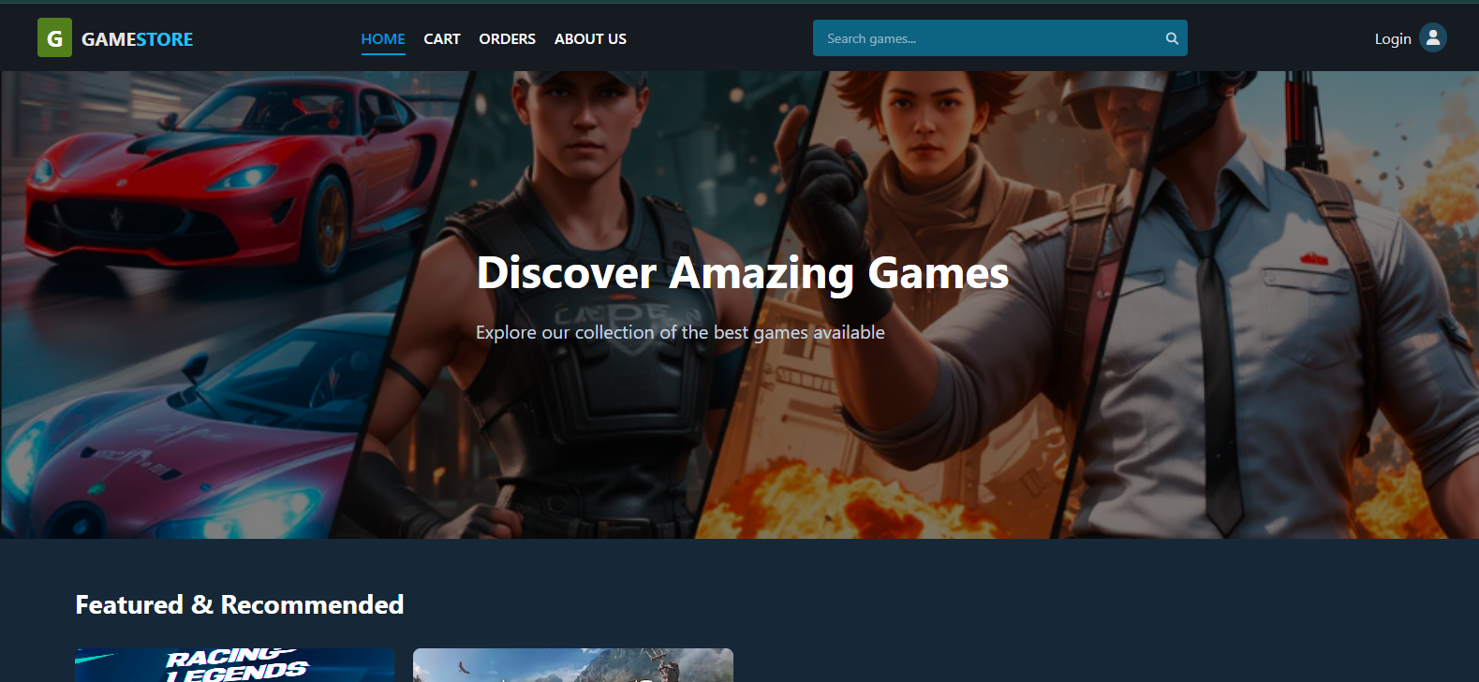

* Login Page:

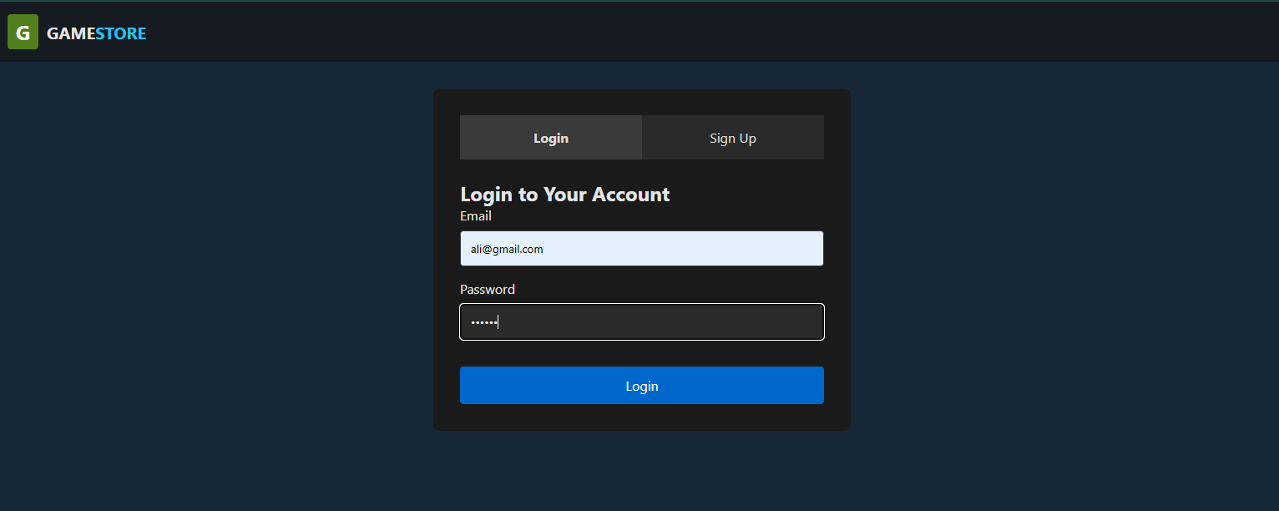

* Cart Page:

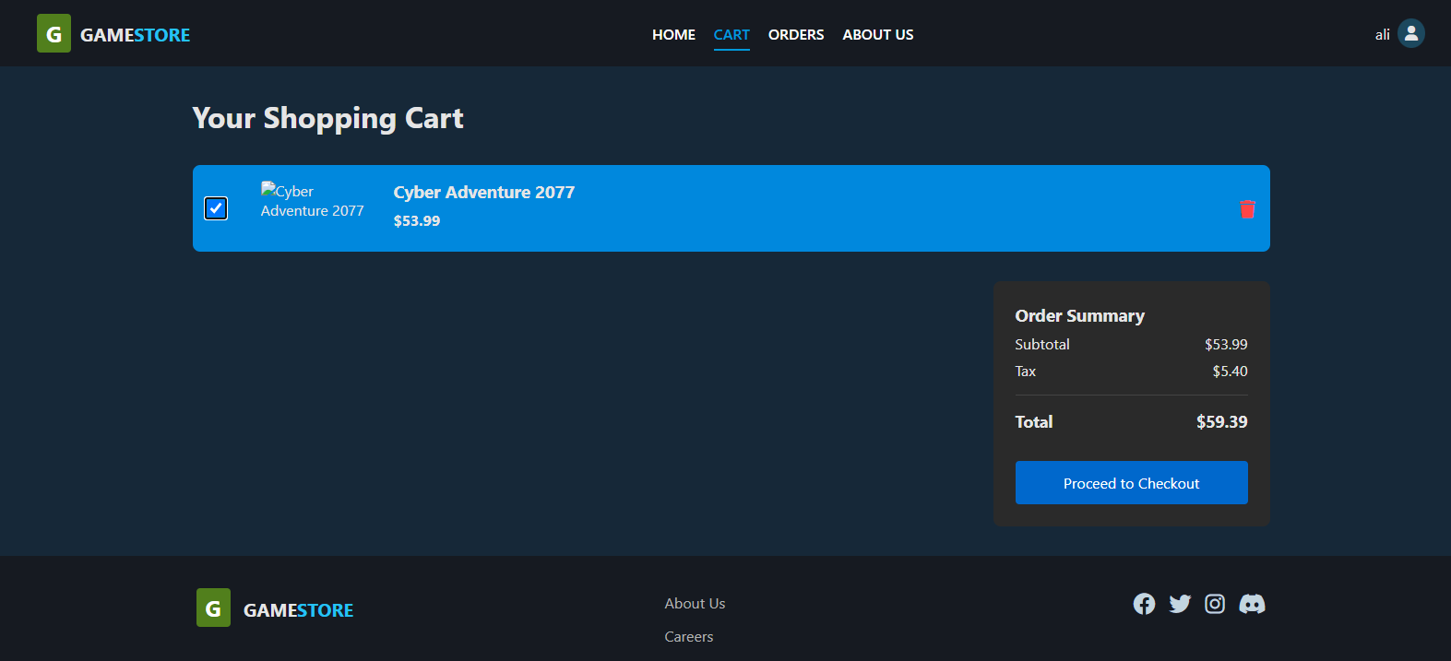

* Order Page:

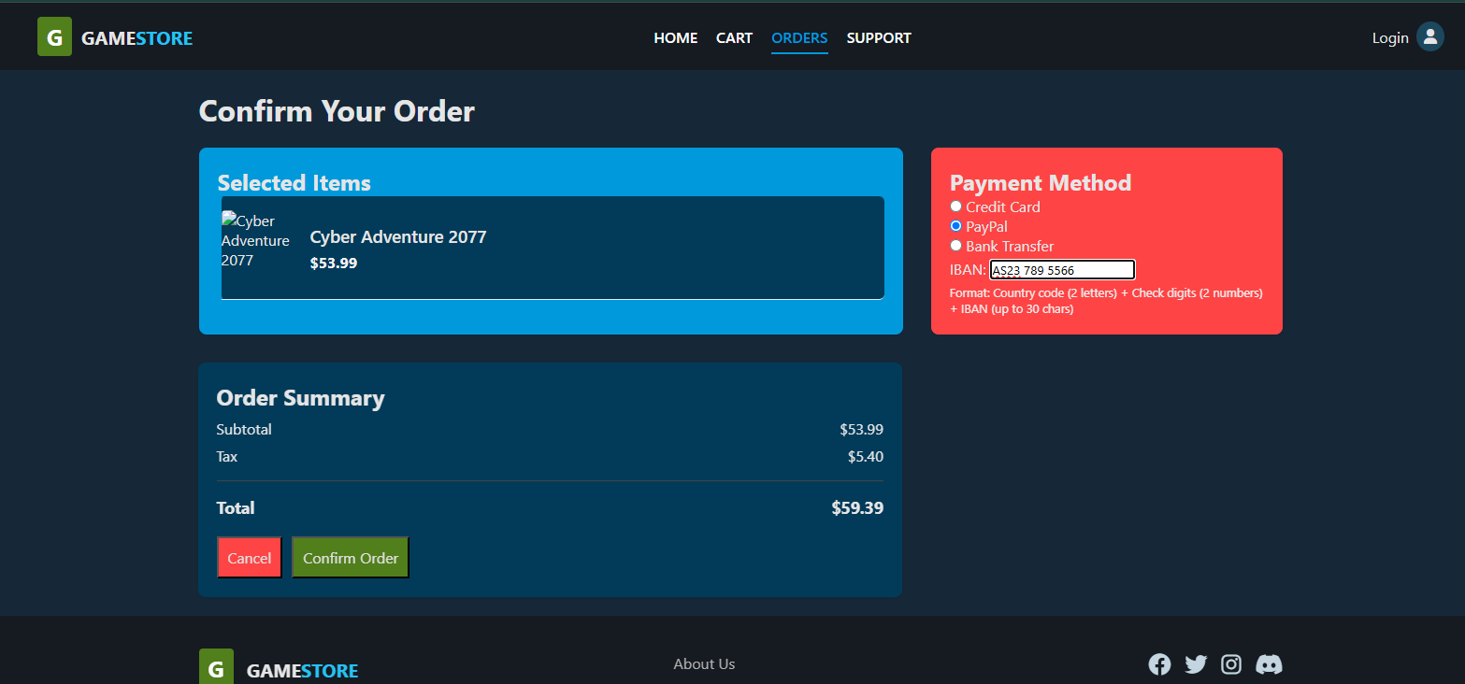

* About Us Page:

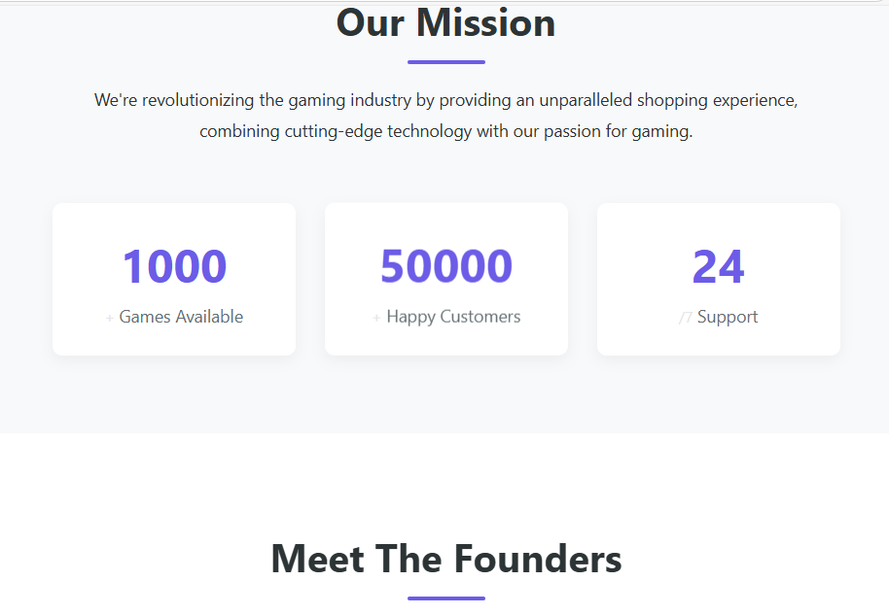

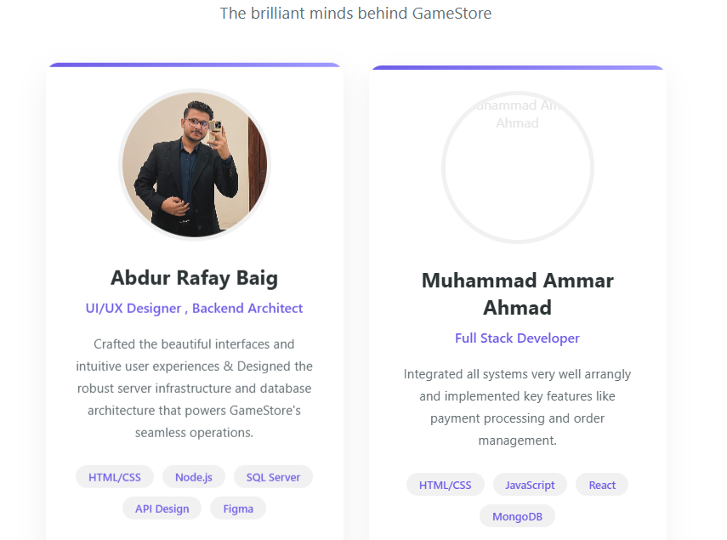

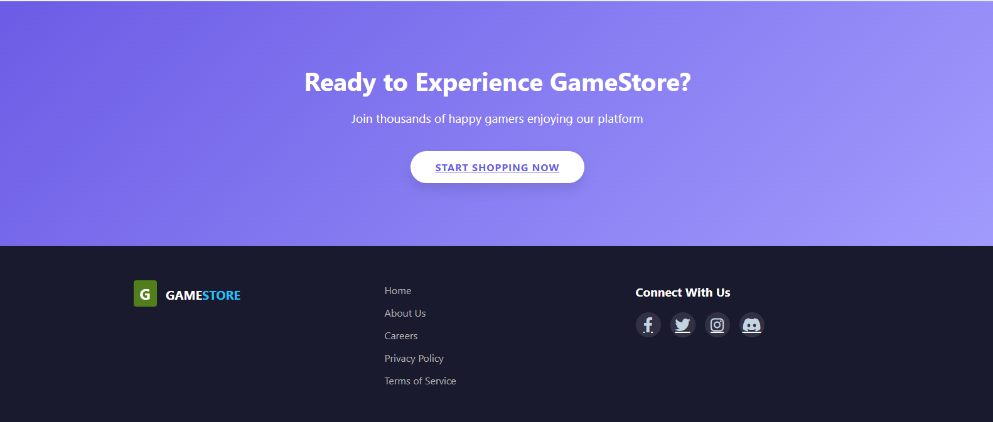

Database Page (Admin Access):



                  